Dublin Technological University,
Certificate, Cloud Solutions Architecture (2020)

Implementation Iteration 2.1
and
Implementation Iteration 2.2 (Page 28)

Student Name: Alan Duffin
Student ID: X00159409

Submission Material
PLEASE visit the video for demostration of progress.
https://s3-eu-west-1.amazonaws.com/appd.cloud.project/IT-Tallaght-Mortgage-Workflow-WebApp-2019-11-23+13-54-23.mp4

Source Code Repository Details
Source Code NodeJS / Lambda | https://github.com/GeneralYeager/tallaght.mortgages/tree/master/tud.mortgages/Tallaght-Mortgages-App
Workflow Cloudformation | https://github.com/GeneralYeager/tallaght.mortgages/blob/master/mortgage.workflow/StateMachineV3.txt
DynamoDB Cloudformation | https://github.com/GeneralYeager/tallaght.mortgages/blob/master/mortgage.dynamo/dynamo-create.yml
Lambda / API Gateway Cloudformation | https://github.com/GeneralYeager/tallaght.mortgages/blob/master/tud.mortgages/Tallaght-Mortgages-App/template.yaml
Angular SPA Source Code | https://github.com/GeneralYeager/tallaght.mortgages/tree/master/mort-app-web
Table A.

Iteration 2.1 Tasks

Building upon last weeks progress report, this document outlines the additional project tasks that have been completed for implementation phase 2. The follow tasks were completed this week.
Project Phase | Service / Area | Implementation Task
Build / Development | AWS Websockets | Human interaction requires notification with User Interface.
Build / Development | AWS Lambda | Build Lambda functions to manage API Gateway Websockets and notifications.
Build / Development | DynamoDB | Build table to manage API Websocket connection tokens.
Build / Development | Angular SPA | Build Browser based Front End to allow users to create/modify/submit Mortgage Applications for workflow assessment.
Test |  | Test Websocket Notification Events and subscriptions
Build / Development | AWS Lambda | Additiona Lambda functions to support Step Function execution.
Build / Development | AWS Step Functions | Extend Step Function state machine to support Human decision making.
Design | AWS Step Functions | Integrate Step Function generation into Cloudformation template.
Test | AWS Step Functions | Test State Transitions / Events
Table B.

I have extended the suite of Lambda services that will allow a the Step function state machine to transition Mortgage application states and allow notification to different user categories (Brokers and Underwriters). In order to support this I have had to build an intial Browser based Single Page Application using the Javascript Angular framework. At this point Brokers can create and amend mortgage applications. I have built Angular services that connect to the AWS API Gateway Websocket API that allows traffic to be initiated either by the client or the server. This is necessary so that uses can be notified of Mortgage application state changes. So users will be notified of State changes and required tasks via two channels SNS (email) and real time browser based websockets.
It has been necessary to build additional Lambda functions to support the integration between the Step Function State Machine and the API Gateway Websocket layer. Also some additional Lambda functions were developed specifically to transition the Mortgage Applications between states.

Plan for Iteration 2.2
Project Phase | Service / Area | Implementation Task
Build / Development | AWS Step Functions | Complete the Step Function Workflow state machine.
Build / Development | AWS Cloudformation | Integrate the deployment of the Workflow state machine into the project Cloud formation template.
Build / Development | AWS Lamda | Build the Lambda Functions to support pausing the workflow to await human decisions. Also manage the Step Function tokens.
Build / Development | DynamoDB | Implement new DB schema to map mortgage application to Step Function execution id. This is required to allow users approve or reject applications without reference to the step function execution id.
Build / Development | Angular | Extends the Browser application to allow submission of mortgages for assessment. Allow for clarification requests and Underwriter decision making.
Test | AWS Step Functions | Test State Transitions / Events / Human interaction
Table C.
The workflow state machine currently exists as seen in Figure AWS.STEP.1
Figure AWS.STEP.1
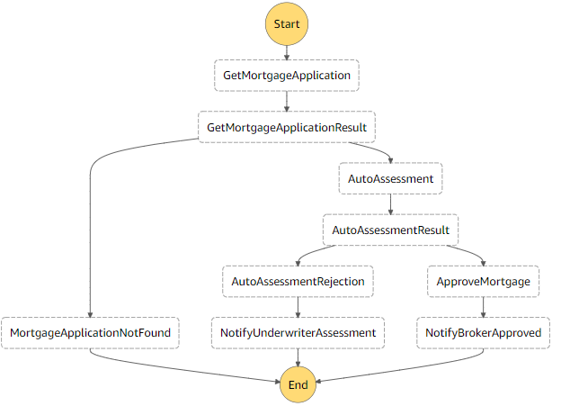

Servlerless / Lambda Functions

The following Lambda functions have now been completed as of this progress report. Figure AWS.LAMBDA.1
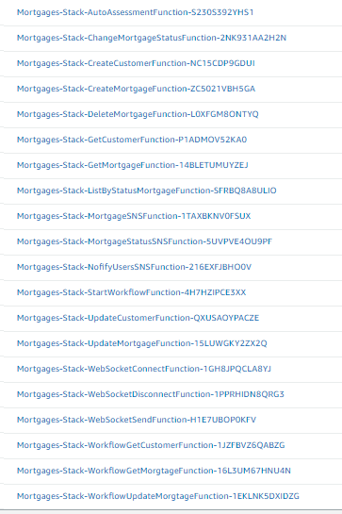
Figure AWS.LAMBDA.1

This table lists the purpose of each of the completed Lambda Functions. Table AWS.LAMBDA.1
Lambda Function | Purpose
Mortgages-Stack-AutoAssessmentFunction | Perform Mortgage Rules check
Mortgages-Stack-ChangeMortgageStatusFunction | Modify the Mortgage Application Status and store.
Mortgages-Stack-CreateCustomerFunction | HTTP API Create Customer
Mortgages-Stack-CreateMortgageFunction | HTTP API Create Mortgage Application
Mortgages-Stack-DeleteMortgageFunction | HTTP API Delete Mortgage Application
Mortgages-Stack-GetCustomerFunction | HTTP API Find By PK Customer
Mortgages-Stack-GetMortgageFunction | HTTP API Find By PK Mortgage Application
Mortgages-Stack-ListByStatusMortgageFunction | HTTP API Find By Status Mortgage Application
Mortgages-Stack-MortgageStatusSNSFunction | Step Function Update Mortgage Status
Mortgages-Stack-NofifyUsersSNSFunction | Step Function Notify State Change
Mortgages-Stack-StartWorkflowFunction | HTTP API Execute Mortgage Workflow
Mortgages-Stack-UpdateCustomerFunction | HTTP API Update Customer
Mortgages-Stack-UpdateMortgageFunction | HTTP API Update Mortgage
Mortgages-Stack-WebSocketConnectFunction | Manage Websocket connection and store token.
Mortgages-Stack-WebSocketDisconnectFunction | Manage Websocket disconnect and delete token.
Mortgages-Stack-WebSocketSendFunction | Step Function send message to API Gateway Websocket for Browser broadcast.
Mortgages-Stack-WorkflowGetCustomerFunction | Step Function Find By PK Customer
Mortgages-Stack-WorkflowGetMorgtageFunction | Step Function Find By PK Mortgage
Mortgages-Stack-WorkflowUpdateMorgtageFunction | Step Function Update Mortgage
Table AWS.LAMBDA.1
The source code and deployment template for these functions are available at the GitHub repository listed in Table A or in the Appendix.
I have had to implement new Lambda functions to manage API Gateway Websocket functionality.

API Gateway WebSockets

Last year AWS announced API Gateway support for the Websocket protocol [12]. This allows for the creation of ...

“bidirectional communication applications using WebSocket APIs in Amazon API Gateway without having to provision and manage any servers.
HTTP-based APIs use a request/response model with a client sending a request to a service and the service responding synchronously back to the client. WebSocket-based APIs are bidirectional in nature. This means that a client can send messages to a service and services can independently send messages to its clients.
This bidirectional behavior allows for richer types of client/service interactions because services can push data to clients without a client needing to make an explicit request. WebSocket APIs are often used in real-time applications such as chat applications, collaboration platforms, multiplayer games, and financial trading platforms.”

The following API Gateway Websocket API has been created. Figure AWS.API.1
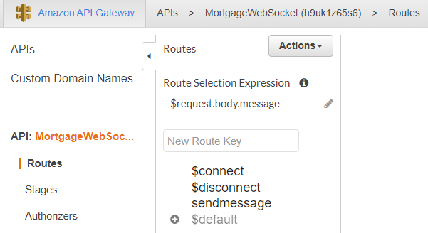

Figure AWS.API.1

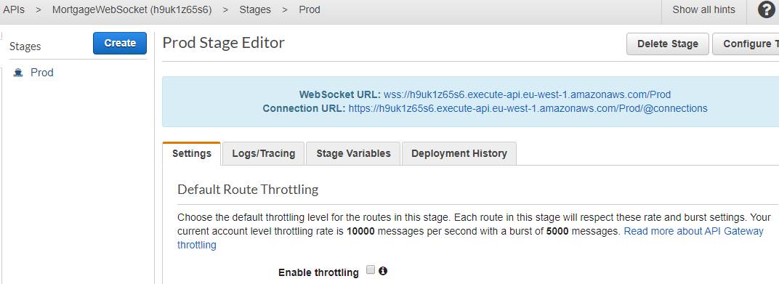
Figure AWS.API.2

Because API Gateway support for Websockets is very recent, the online help is minimal. It took many hours to get the deployment and develoment correct.

There were many errors encountered such as incorrect endpoint format and futile attempts to get Lambda functions to establish wss protocol connections.

This error was caused by an invalid endpoint format.
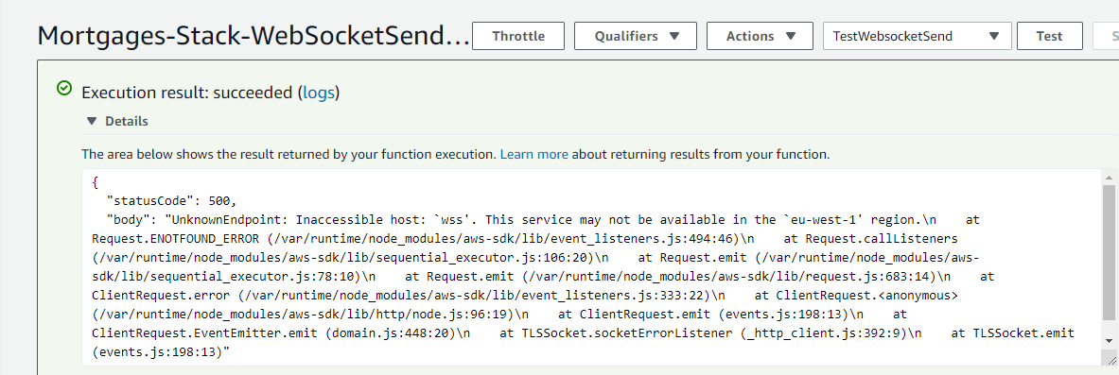
Figure AWS.SOCKET.1

It is not possible for Lambda functions to connect to an external WSS endpoint. They must directly use the 'AWS.ApiGatewayManagementApi' sdk and connect via the API Gateway instance.

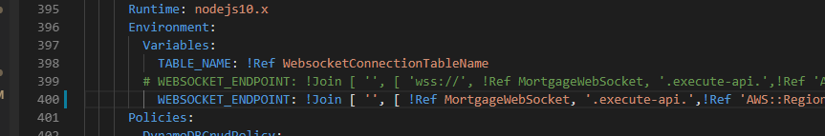
Figure AWS.SOCKET.2

Websocket Success. Figure AWS.SOCKET.3
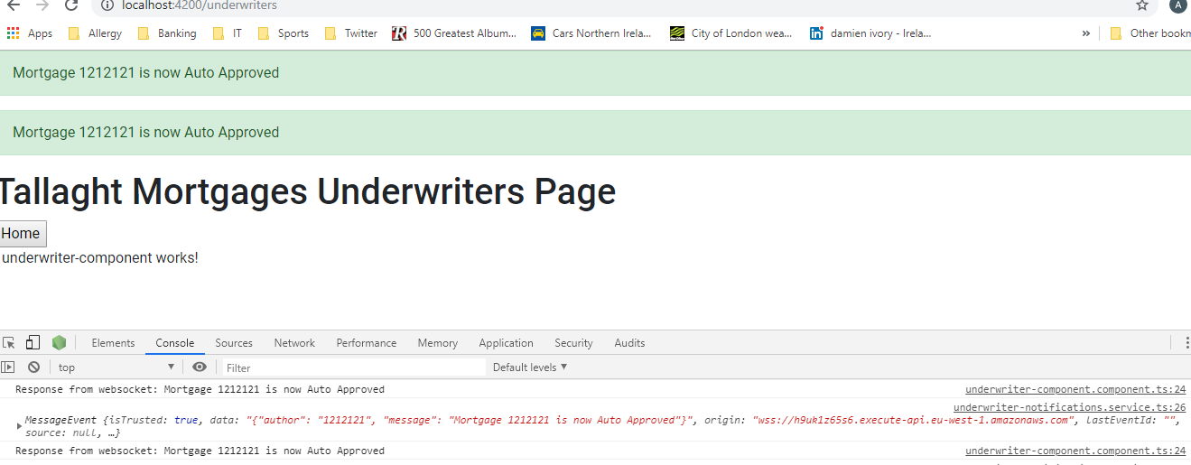
Figure AWS.SOCKET.3

Socket Broadcast Source Code:

exports.handler = async (event, context) => {
let connectionData;
console.log(event);
try {
connectionData = await ddb.scan({ TableName: TABLE_NAME, ProjectionExpression: 'connectionId' }).promise();
} catch (e) {
return { statusCode: 500, body: e.stack };
}

const apigwManagementApi = new AWS.ApiGatewayManagementApi({
apiVersion: '2018-11-29',
endpoint: WEBSOCKET_ENDPOINT //event.requestContext.domainName + '/' + event.requestContext.stage
});

//const postData = JSON.parse(event.body).data;
const postData = '{\"author\": \"1212121", \"message\": \"Mortgage 1212121 is now Auto Approved"}';

const postCalls = connectionData.Items.map(async ({ connectionId }) => {
try {
await apigwManagementApi.postToConnection({ ConnectionId: connectionId, Data: postData }).promise();
} catch (e) {
if (e.statusCode === 410) {
console.log(`Found stale connection, deleting ${connectionId}`);
await ddb.delete({ TableName: TABLE_NAME, Key: { connectionId } }).promise();
} else {
throw e;
}
}
});

try {
await Promise.all(postCalls);
} catch (e) {
return { statusCode: 500, body: e.stack };
}

return { statusCode: 200, body: 'Data sent.' };
};

Web Browser Websocket Connection Source Code:
import { Injectable } from '@angular/core';

import { Observable, Observer, Subject } from 'rxjs'

@Injectable({
providedIn: 'root'
})
export class WebsocketService {
constructor() {}

private subject: Subject<MessageEvent>;

public connect(url): Subject<MessageEvent> {
console.log("connect url");
if (!this.subject) {
this.subject = this.create(url);
console.log("Successfully connected: " + url);
}
return this.subject;
}

private create(url): Subject<MessageEvent> {
let ws = new WebSocket(url);
console.log("create ws");
let observable = Observable.create((obs: Observer<MessageEvent>) => {
console.log("in obs");
//ws.onmessage = obs.next.bind(obs);
ws.onmessage = function(event) {
console.log("WebSocket message received:", event);
obs.next(event);
};
ws.onerror = obs.error.bind(obs);
ws.onclose = obs.complete.bind(obs);
return ws.close.bind(ws);
});
let observer = {
next: (data: Object) => {
console.log("in next");
if (ws.readyState === WebSocket.OPEN) {
ws.send(JSON.stringify(data));
}
}
};
return Subject.create(observer, observable);
}
}

Angular Single Page Application

In order to build a Javascript based Bowser application to demonstrate and interact with the Step Function Workflow I have built a first iteration of an Angular SPA application.

Steps to set up the development environment are:
1 Install npm. https://nodejs.org/en/
2 Install Angular CLI. https://angular.io/guide/setup-local
3 Install Angular Material Design. https://material.angular.io/guide/getting-started
4 Install Websocket NPM Package. https://www.npmjs.com/package/websocket
5 The source code completed so far is stored in Git Hub.

At the moment the SPA allows users to create / modify / list mortgage application. View Websocket notifications.
The look and feel is very basic but will be sufficient to provide a working system.

Run the SPA locally – shown below.
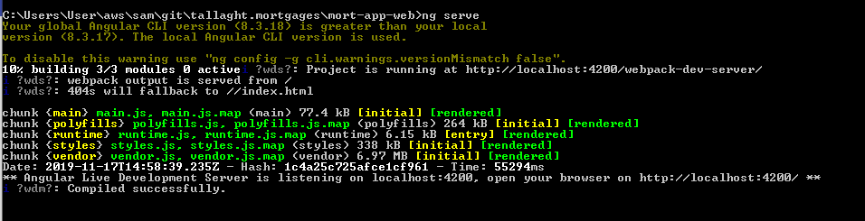
Figure AWS.ANGULAR.1

Home Page. Figure AWS.ANGULAR.2
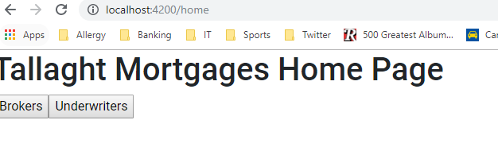
Broker Page. Figure AWS.ANGULAR.3
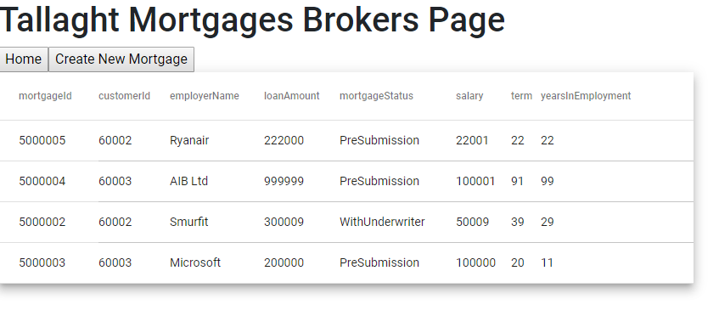

Modify Morgages. Figure AWS.ANGULAR.4
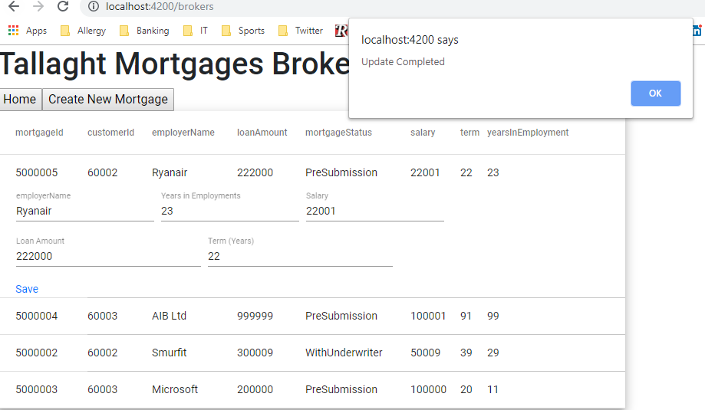

Recieve Mortgage Status Notifications. Figure AWS.LAMBDA.5
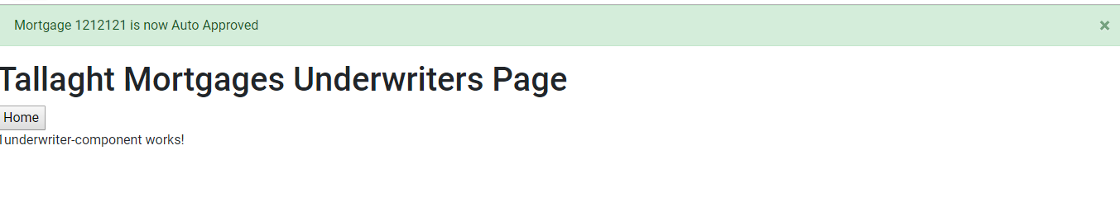

Cross-Origin Resource Sharing (CORS) is a mechanism that uses additional HTTP headers to tell browsers to give a web application running at one origin, access to selected resources from a different origin. A web application executes a cross-origin HTTP request when it requests a resource that has a different origin (domain, protocol, or port) from its own.
https://developer.mozilla.org/en-US/docs/Web/HTTP/CORS

The AWS documentation enabling CORS on API Gateway via Cloudformation is lacking. It took a couple of days for me to get the HTTP API calls working from my local development environment.

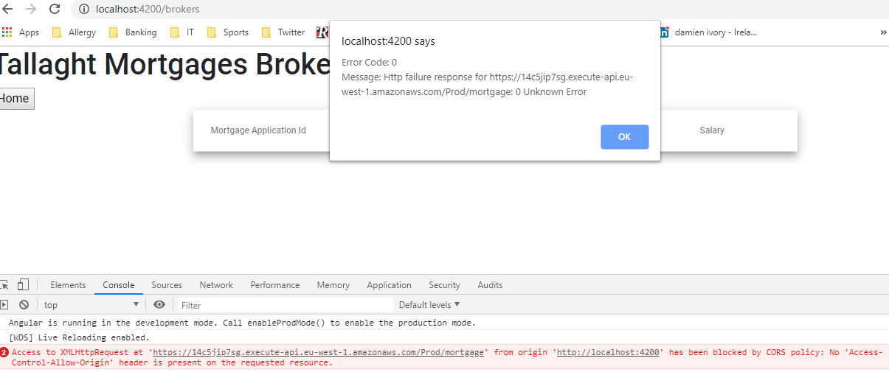
Figure AWS.CORS.1

Attempt to enable CORS post deployment.
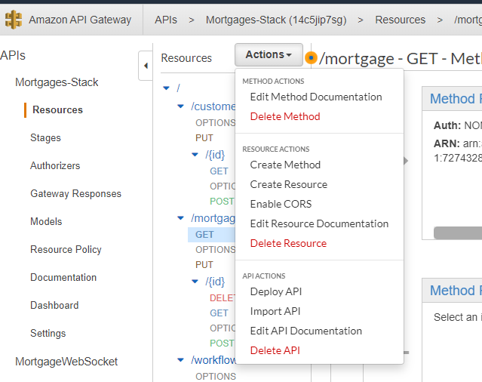
Figure AWS.CORS.2

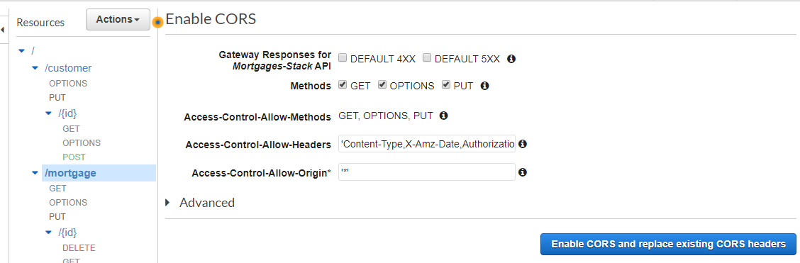
Figure AWS.CORS.3

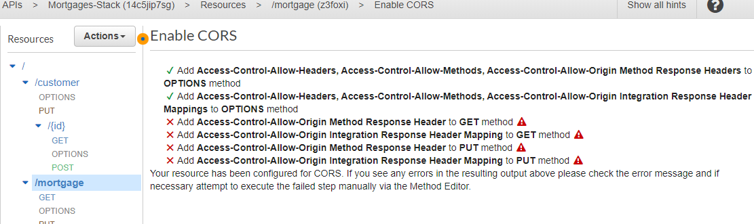
Figure AWS.CORS.4

Some sites indicated that the correct Cloudformation format to enable CORS for API Gateway as shown below.
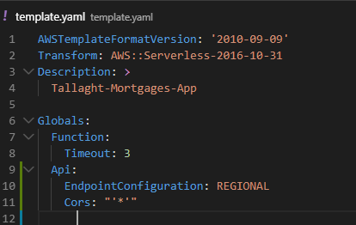
Figure AWS.CORS.5

After much web surfing and trial and error the correct template is shown below:
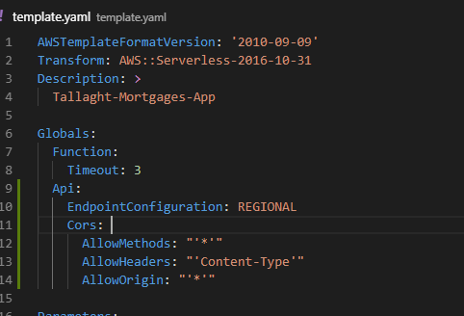
Figure AWS.CORS.6

API Gateway with Lambda integration (rather than HTTP integration) does not fully abstract out CORS functionality. Individual Lambda function must add CORS headers as seen in Figure AWS.CORS.7

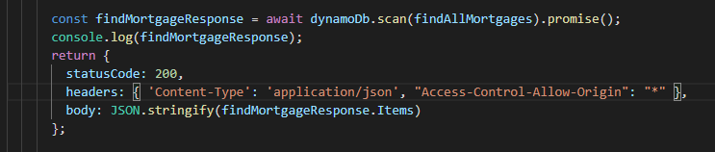
Figure AWS.CORS.7

Development – Workflow Implmentation – Step Function.

The second iteration of the Step Function State Machine was shown in Figure AWS.STEP.1

The workflow has been extended only slightly this week but in the coming week I hope to have completed the workflow by adding the following steps:
1 Add Clarification, Rejection and Approval processes based on the human underwriter decision.
2 Pause the workflow when the Mortgage Application is assigned to a human underwriter.
3 Pause the workflow when the Mortgage Application is returned to the Broker for clarification.
4 Associate the workflow restart token with the mortgage Id and persist to DynamoDB.
5 Complete all of the Websocket and SNS notification paths.
6 Integrate with the Browser SPA, allow users to start and restart the workflow process.

The small enhancements that I have completed for the state machine this week have allowed me to become more familiar with the Step Function functionality and notation. It is very important to have a clear design for the input and outputs of each Task/Lambda functionmethod and the transformations that are required between Tasks to allow subsequent tasks in the workflow to access the required data.

The testing and bug fixing that I performed is summarised now in the following snapshots of two scenarios : Auto Assessment rejection and Auto Assessment success.

Auto Assessment Rejection

Submit a Mortgage Application that does not meet the Auto Assessment requirements. Figure AWS.AUTO.1
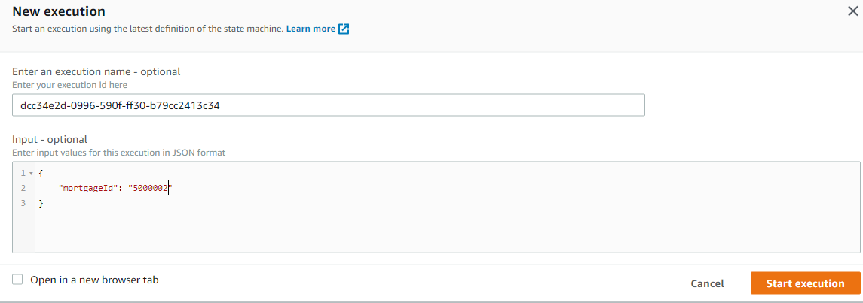
Figure AWS.AUTO.1

Invalid JSON path.

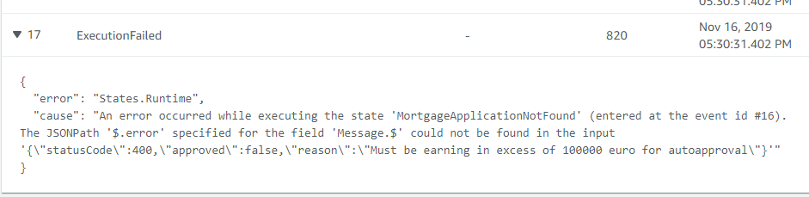

The InputPath on the Task must isolate the required JSON node to provide the correct input to the Lambda function. Figure AWS.AUTO.2
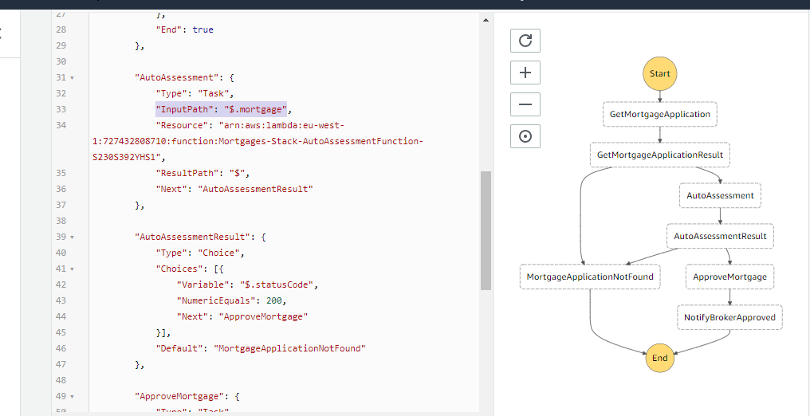
Figure AWS.AUTO.2

Also the Lambda Fucntion must return any and all data that is required for the next task in the chain. Figure AWS.AUTO.3
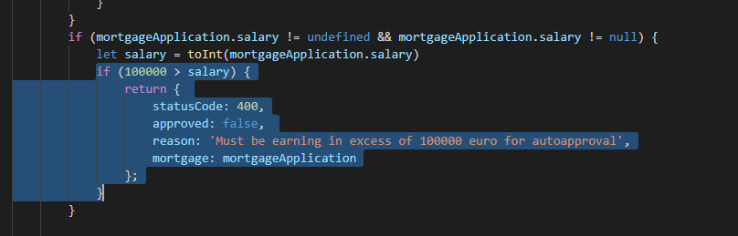
Figure AWS.AUTO.3

If the input and output data is not correctly mediated then the Step Function execution will fail. Figure AWS.AUTO.4
Figure AWS.AUTO.4

The AWS Console will highlight failed states as shown below. Figure AWS.AUTO.5
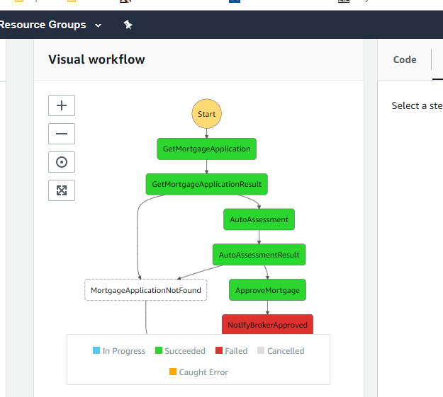
Figure AWS.AUTO.5

Another badly formatted Step Function Task input. Figure AWS.AUTO.6
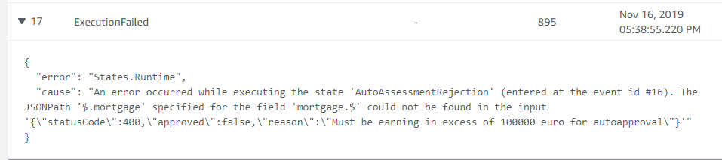
Figure AWS.AUTO.6

Once these errors are rectified then the Step Function execution will success. Figure AWS.AUTO.7
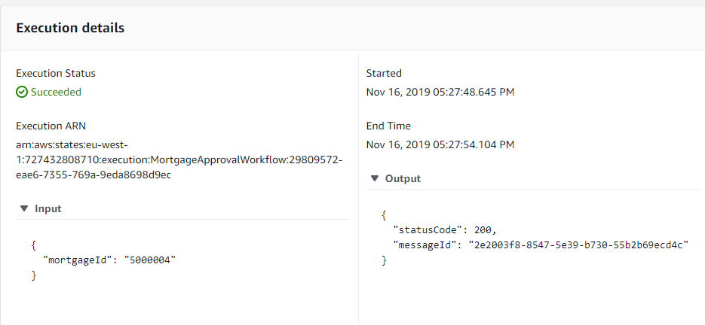
Figure AWS.AUTO.5

The Step Function output correctly shows that the last Task returned a 200 status completion code and also the ID of the SNS message that was send to the users.

However another coding error show that the new state is not correctly rendered in the email. Figure AWS.AUTO.6
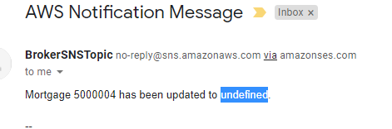
Figure AWS.AUTO.6

Once resolved we see the correct message in the email. Figure AWS.AUTO.7
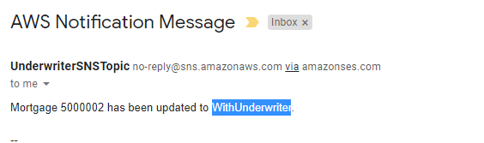
Figure AWS.AUTO.7

The mortgage application has also been correctly updated in DynamoDB. Figure AWS.AUTO.8

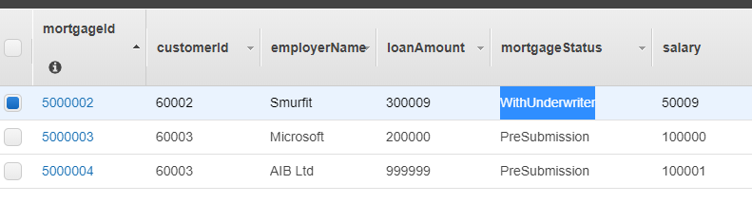
Figure AWS.AUTO.8

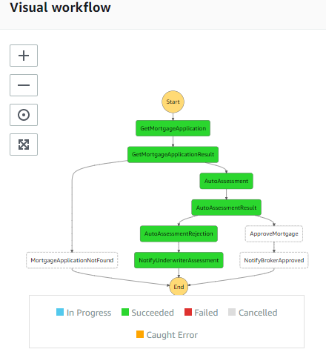
The Step Function execution shows the sequence of tasks.

Auto Assessment Success
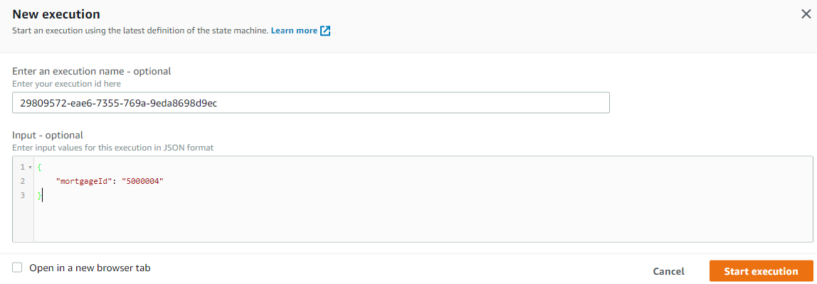
Select a Mortgage Application that meets ALL Auto Assessment criteria. Figure AWS.AUTO.9
Figure AWS.AUTO.9

Successful email SNS Notification. Figure AWS.AUTO.10

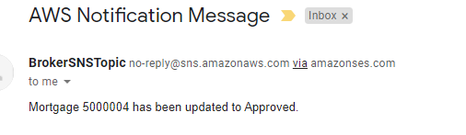
Figure AWS.AUTO.10

DynamoDB has also been updated. Figure AW.S.AUTO.11
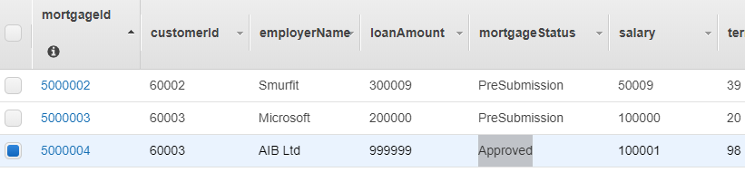
Figure AW.S.AUTO.11

Again the Step Function execution diagram shows the sequene of events. Figure AWS.AUTO.12
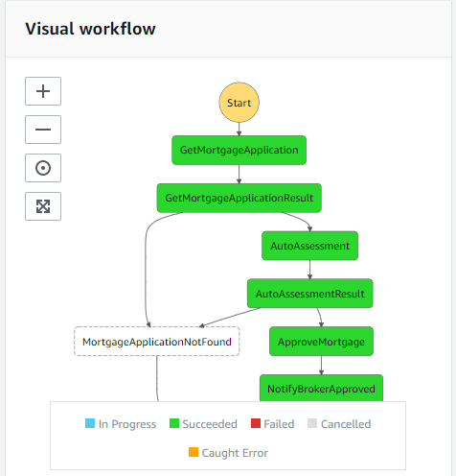
Figure AWS.AUTO.12

Progress for Second Week of Iteration Two.

Iteration 2.2 Tasks

Building upon last weeks progress report, this document outlines the additional project tasks that have been completed this week for the final implementation phase 2 submission. The follow tasks were completed this week.
Project Phase | Service / Area | Implementation Task
Build / Development | AWS Step Functions | Significantly refactor the Step Function Workflow state machine. The original design of the workflow was done without a full understanding of the details and limitations of the State Machine Definition Language in terms of data state and mediation.
Build / Development | AWS Cloudformation | I have not had time to integrate the deployment of the Workflow state machine into the project Cloud formation template.
Build / Development | AWS Lamda | Completed the development of Lambda Functions to allow workflow to await human/underwriting decisions.
Build / Development | DynamoDB | Implement new DB schema to map mortgage application to Step Function execution id. This is required to allow users approve or reject applications without reference to the step function execution id.
Build / Development | Angular | Extends the Browser application to allow submission of mortgages for assessment. I have not had time to extend the functionality to allow for clarification requests.
Test | AWS Step Functions | Test State Transitions / Events / Human interaction
Table D.

Definining the data inputs and outputs of each State within the Step Function workflow requires working within the restrictions of the unility functions provided by the State Machine Definition Language [13]. Input and Output processing [14] must be done using the 3 processing methods : InputPath, ResultPath and OutputPath. These can be restrictive and documentation for complex scenarios is not easily available even within the Step Function Developer Guide [15]. Integration with existing Lambda functions (especially if they where written to used as HTTP endpoints) can require tricky data manipulation. For my Workflow definition I needed to maintain the Mortgage state data and pass it through every state, which does not happen by default as the Lambda output will overwrite the State data if the Lambda result is not saved to a distinct javascript element / node to avoid overwrites. Also removing stale or State specific data can require for example a Pass state that can build new data state for the next state.

Plan for Iteration 3.1
Project Phase | Service / Area | Implementation Task
Build / Development | AWS Step Functions | Extend the Step Function Workflow state machine to support Underwriting Clarification requests to the Broker to allow questions be submitted and answered regarding the mortgage application or applicant. The Broker must then be able to restart the workflow.
Build / Development | AWS Lambda | Add persistance to the Step Function tokens to allow users to restart the state machine execution from the Browser. Use either SQS or DynamoDB or both.
Build / Development | AWS S3 / Angular | Add Underwriter screens to the Front end app to allow the brokers to perform their tasks.
Build / Development | AWS S3 / Angular | Build new screens to allow underwriters to submit clarification questions and for the brokers to answer.
Build / Development | AWS Cloudformation | Integrate the deployment of the Workflow state machine into the project Cloud formation template.
Test | AWS Step Functions | Test State Transitions / Events / Human interaction
Table E.

Iteration 2 Submission Workflow State Machine

The workflow state machine currently exists as seen in Figure AWS.STEP.2.1
Figure AWS.STEP.2.1

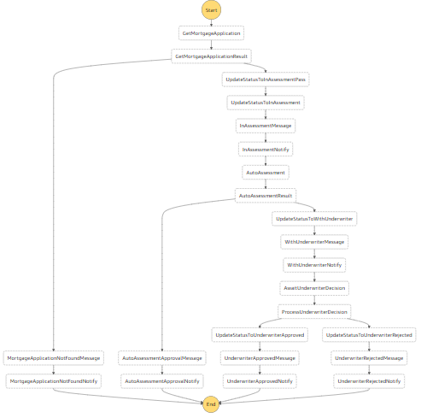

Iteration 2 Submission Technical Architecture

The overall current technical architecture is outlined in Figure AWS.2.2
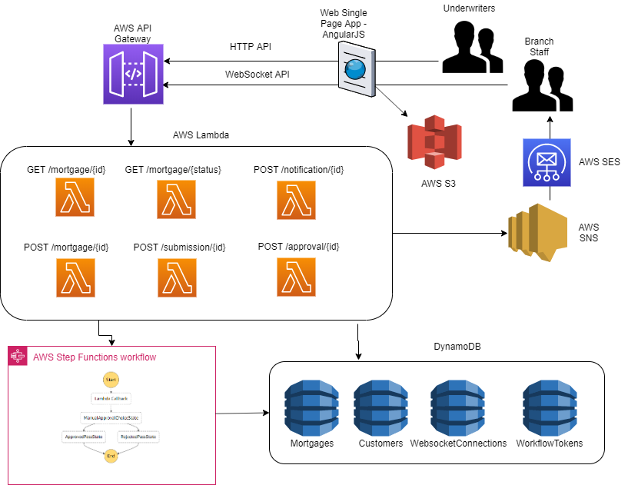
Figure AWS.2.2

Iteration 2 Lambda Functions

This table lists the new Lambda functions that I have developed this week in addition to those already developed (previously listed in Table AWS.LAMBDA.1). Table AWS.LAMBDA.2.1
Lambda Function | Purpose
CreateNotificationMessageFunction | This function is used by many states in the workflow to develop appropriate situational notification messages for brokers and underwriters to give them clarity on the current processing state of the mortgage application.
ReceiveUnderwriterDecisionEmailFunction | The Lambda function is exposed as a HTTP API via API Gateway to allow the Underwriter to submit their decision and restart the Workflow execution to process that decision.
SendNotificationMessageFunction | This function is used in combination with CreateNotificationMessageFunction to send the generated message to the approriate SNS topic and the Websocket API for transmision to all connected browser apps.
SendUnderwriterDecisionEmailFunction | The Lambda function is called from the State Machine waitForTask State. It will generate the notification email to allow the underwriter to approve or reject the application. The email will contain the ReceiveUnderwriterDecisionEmailFunction HTTP API endpoint.
Table AWS.LAMBDA.2.1
The source code and deployment template for these functions are available at the GitHub repository listed in Table A or in the Appendix.

Iteration 2 Workflow Human Decisions

This week I built out the functionality to allow the Step Function workflow to pause its execution to allow for Human decision making. Initially I followed to online documentation [16] to build a small test case. Figure AWS.STEP.2.1

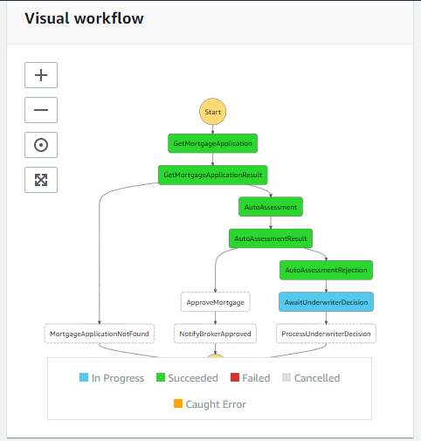
Figure AWS.STEP.2.1

The input to the execution is the Mortgage Id. Figure AWS.STEP.2.2
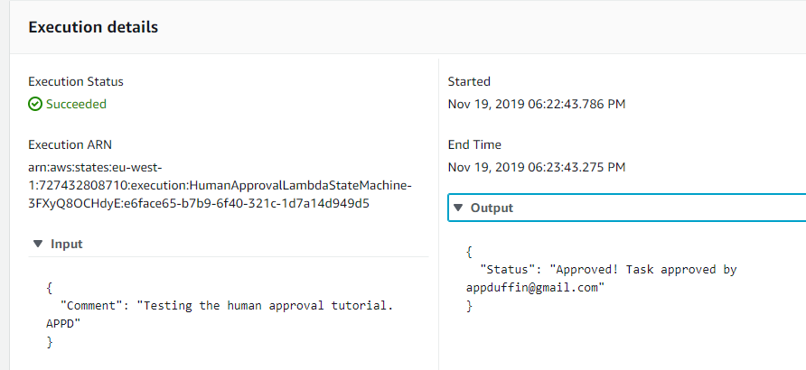
Figure AWS.STEP.2.2

During execution we can see that the state will pause waiting for a Human decision. Figure AWS.STEP.2.3

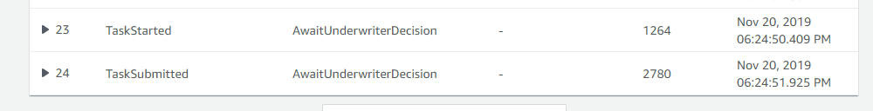
Figure AWS.STEP.2.3

The email is delivered to the registered email address and contains embeded URLs that the underwriter can use to either Approve or reject the application. Figure AWS.STEP.2.4
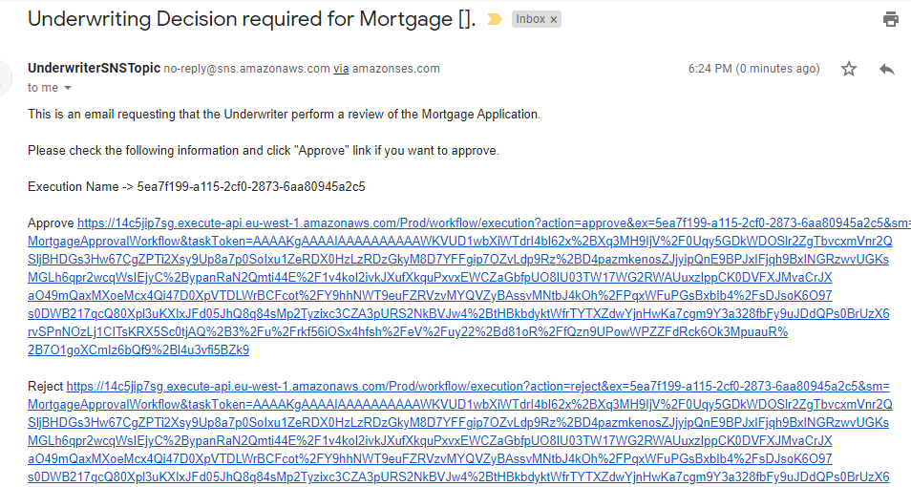
Figure AWS.STEP.2.4

Appendices

The following sections list some key / interesting source code / template snippets.

WebSocket Cloudformation Template
AWSTemplateFormatVersion: '2010-09-09'
Transform: AWS::Serverless-2016-10-31
Description: >
Tallaght-Mortgages-App

Globals:
Function:
Timeout: 3
Api:
EndpointConfiguration: REGIONAL
Cors:
AllowMethods: "'*'"
AllowHeaders: "'Content-Type'"
AllowOrigin: "'*'"

Parameters:
LambdaRoleParameter:
Type: String
Default: "arn:aws:iam::727432808710:role/TUD.Mortgage.Lambda.Role"
Description: Enter the ARN of an applicable IAM Role for the Lambda Functions
StepFunctionArnParameter:
Type: String
Default: "arn:aws:states:eu-west-1:727432808710:stateMachine:MortgageApprovalWorkflow"
Description: Enter the ARN of the Workflow Step Function State Machine
WebsocketConnectionTableName:
Type: String
Default: 'WEBSOCKET_CONNECTIONS_TABLE'
StepFunctionTokenTableName:
Type: String
Default: 'STEPFUNCTION_TOKEN_TABLE'

Resources:

# SNS TOPICS
UnderwriterSNSTopic:
Type: AWS::SNS::Topic
Properties:
DisplayName: UnderwriterSNSTopic
Subscription:
- Endpoint: appduffin@gmail.com
Protocol: email
TopicName: UnderwriterSNSTopic
BrokerSNSTopic:
Type: AWS::SNS::Topic
Properties:
DisplayName: BrokerSNSTopic
Subscription:
- Endpoint: appduffin@gmail.com
Protocol: email
TopicName: BrokerSNSTopic

# CUSTOMER APIS
GetCustomerFunction:
Type: AWS::Serverless::Function
Properties:
CodeUri: customers/
Handler: get.get
Runtime: nodejs10.x
Role:
Ref: LambdaRoleParameter
Events:
GetCustomerEvent:
Type: Api
Properties:
Path: /customer/{id}
Method: GET
CreateCustomerFunction:
Type: AWS::Serverless::Function
Properties:
CodeUri: customers/
Handler: create.create
Runtime: nodejs10.x
Role:
Ref: LambdaRoleParameter
Events:
CreateCustomerEvent:
Type: Api
Properties:
Path: /customer/
Method: PUT
UpdateCustomerFunction:
Type: AWS::Serverless::Function
Properties:
CodeUri: customers/
Handler: update.update
Runtime: nodejs10.x
Role:
Ref: LambdaRoleParameter
Events:
UpdateCustomerEvent:
Type: Api
Properties:
Path: /customer/{id}
Method: POST

# MORTGAGE APIS
GetMortgageFunction:
Type: AWS::Serverless::Function
Properties:
CodeUri: mortgages/
Handler: get.get
Runtime: nodejs10.x
Role:
Ref: LambdaRoleParameter
Events:
GetMortgageEvent:
Type: Api
Properties:
Path: /mortgage/{id}
Method: GET
CreateMortgageFunction:
Type: AWS::Serverless::Function
Properties:
CodeUri: mortgages/
Handler: create.create
Runtime: nodejs10.x
Role:
Ref: LambdaRoleParameter
Events:
CreateMortgageEvent:
Type: Api
Properties:
Path: /mortgage/
Method: PUT
UpdateMortgageFunction:
Type: AWS::Serverless::Function
Properties:
CodeUri: mortgages/
Handler: update.update
Runtime: nodejs10.x
Role:
Ref: LambdaRoleParameter
Events:
CreateMortgageEvent:
Type: Api
Properties:
Path: /mortgage/{id}
Method: POST
DeleteMortgageFunction:
Type: AWS::Serverless::Function
Properties:
CodeUri: mortgages/
Handler: delete.delete
Runtime: nodejs10.x
Role:
Ref: LambdaRoleParameter
Events:
DeleteMortgageEvent:
Type: Api
Properties:
Path: /mortgage/{id}
Method: DELETE
ListByStatusMortgageFunction:
Type: AWS::Serverless::Function
Properties:
CodeUri: mortgages/
Handler: list.list
Runtime: nodejs10.x
Role:
Ref: LambdaRoleParameter
Events:
ListByStatusMortgageEvent:
Type: Api
Properties:
Path: /mortgage/
Method: GET

# STEP FUNCTION HUMAN TOKEN DYNAMO DB TABLE
StepFunctionTokenTable:
Type: AWS::DynamoDB::Table
Properties:
TableName: !Ref StepFunctionTokenTableName
AttributeDefinitions:
- AttributeName: "mortgageId"
AttributeType: "S"
# - AttributeName: "stepFunctionToken"
# AttributeType: "S"
KeySchema:
- AttributeName: "mortgageId"
KeyType: "HASH"
BillingMode: PAY_PER_REQUEST

# WORKFLOW APIS
NofifyUsersSNSFunction:
Type: AWS::Serverless::Function
Properties:
Handler: stepfunctions/notifications/snsNotifications.handler
Runtime: nodejs10.x
Role:
Ref: LambdaRoleParameter
Environment:
Variables:
UNDERWRITER_TOPIC_ARN: !Ref UnderwriterSNSTopic
BROKER_TOPIC_ARN: !Ref BrokerSNSTopic
DependsOn:
- UnderwriterSNSTopic
- BrokerSNSTopic

CreateNotificationMessageFunction:
Type: AWS::Serverless::Function
Properties:
Handler: stepfunctions/notifications/notificationMessages.handler
Runtime: nodejs10.x
Role:
Ref: LambdaRoleParameter
Environment:
Variables:
UNDERWRITER_TOPIC_ARN: !Ref UnderwriterSNSTopic
BROKER_TOPIC_ARN: !Ref BrokerSNSTopic
DependsOn:
- UnderwriterSNSTopic
- BrokerSNSTopic

SendNotificationMessageFunction:
Type: AWS::Serverless::Function
Properties:
Handler: stepfunctions/notifications/sendNotifications.handler
Runtime: nodejs10.x
# Role:
# Ref: LambdaRoleParameter
Environment:
Variables:
TABLE_NAME: !Ref WebsocketConnectionTableName
WEBSOCKET_ENDPOINT: !Join [ '', [ !Ref MortgageWebSocket, '.execute-api.',!Ref 'AWS::Region','.amazonaws.com/Prod'] ]
Policies:
- DynamoDBCrudPolicy:
TableName: !Ref WebsocketConnectionTableName
- Statement:
- Effect: Allow
Action:
- 'sns:*'
Resource:
- '*'
- Statement:
- Effect: Allow
Action:
- 'execute-api:ManageConnections'
Resource:
- !Sub 'arn:aws:execute-api:${AWS::Region}:${AWS::AccountId}:${MortgageWebSocket}/*'
DependsOn:
- UnderwriterSNSTopic
- BrokerSNSTopic
- WebsocketConnectionsTable
- MortgageWebSocket

WorkflowGetCustomerFunction:
Type: AWS::Serverless::Function
Properties:
Handler: stepfunctions/customers/findByPK.handler
Runtime: nodejs10.x
Role:
Ref: LambdaRoleParameter
WorkflowGetMorgtageFunction:
Type: AWS::Serverless::Function
Properties:
Handler: stepfunctions/mortgages/findByPK.handler
Runtime: nodejs10.x
Role:
Ref: LambdaRoleParameter
WorkflowUpdateMorgtageFunction:
Type: AWS::Serverless::Function
Properties:
Handler: stepfunctions/mortgages/updateMortgage.handler
Runtime: nodejs10.x
Role:
Ref: LambdaRoleParameter
StartWorkflowFunction:
Type: AWS::Serverless::Function
Properties:
Handler: stepfunctions/startWorkflow.handler
Runtime: nodejs10.x
Role:
Ref: LambdaRoleParameter
Environment:
Variables:
MORTGAGE_WORKFLOW_ARN: !Ref StepFunctionArnParameter
Events:
StartWorkflowEvent:
Type: Api
Properties:
Path: /workflow/execution
Method: PUT
AutoAssessmentFunction:
Type: AWS::Serverless::Function
Properties:
Handler: workflow/autoassessment.handler
Runtime: nodejs10.x
Role:
Ref: LambdaRoleParameter
ChangeMortgageStatusFunction:
Type: AWS::Serverless::Function
Properties:
Handler: stepfunctions/mortgages/changeMortgageStatus.handler
Runtime: nodejs10.x
Role:
Ref: LambdaRoleParameter
MortgageStatusSNSFunction:
Type: AWS::Serverless::Function
Properties:
Handler: stepfunctions/notifications/mortgageStatusSend.handler
Runtime: nodejs10.x
Role:
Ref: LambdaRoleParameter
SendUnderwriterDecisionEmailFunction:
Type: AWS::Serverless::Function
Properties:
Handler: workflow/sendUnderwriterApprovalEmail.handler
Runtime: nodejs10.x
Role:
Ref: LambdaRoleParameter
Environment:
Variables:
UNDERWRITER_DECISION_API: !Sub "https://${ServerlessRestApi}.execute-api.${AWS::Region}.amazonaws.com/Prod/workflow/execution"
# UNDERWRITER_DECISION_API: !Join [ 'https://', [ !Ref ServerlessRestApi, '.execute-api.',!Ref 'AWS::Region','.amazonaws.com/Prod/workflow/execution'] ]
UNDERWRITER_TOPIC_ARN: !Ref UnderwriterSNSTopic

ReceiveUnderwriterDecisionEmailFunction:
Type: AWS::Serverless::Function
Properties:
Handler: workflow/receiveUnderwriterDecision.handler
Runtime: nodejs10.x
Role:
Ref: LambdaRoleParameter
Events:
UnderwriterDecisionEvent:
Type: Api
Properties:
Path: /workflow/execution
Method: GET

# WEBSOCKET APIS
MortgageWebSocket:
Type: AWS::ApiGatewayV2::Api
Properties:
Name: MortgageWebSocket
ProtocolType: WEBSOCKET
RouteSelectionExpression: "$request.body.message"
ConnectRoute:
Type: AWS::ApiGatewayV2::Route
Properties:
ApiId: !Ref MortgageWebSocket
RouteKey: $connect
AuthorizationType: NONE
OperationName: ConnectRoute
Target: !Join
- '/'
- - 'integrations'
- !Ref MortgateConnectionIntegration
MortgateConnectionIntegration:
Type: AWS::ApiGatewayV2::Integration
Properties:
ApiId: !Ref MortgageWebSocket
Description: Connect Integration
IntegrationType: AWS_PROXY
IntegrationUri:
Fn::Sub:
arn:aws:apigateway:${AWS::Region}:lambda:path/2015-03-31/functions/${WebSocketConnectFunction.Arn}/invocations
DisconnectRoute:
Type: AWS::ApiGatewayV2::Route
Properties:
ApiId: !Ref MortgageWebSocket
RouteKey: $disconnect
AuthorizationType: NONE
OperationName: DisconnectRoute
Target: !Join
- '/'
- - 'integrations'
- !Ref MortgateDisconnectInteg
MortgateDisconnectInteg:
Type: AWS::ApiGatewayV2::Integration
Properties:
ApiId: !Ref MortgageWebSocket
Description: Disconnect Integration
IntegrationType: AWS_PROXY
IntegrationUri:
Fn::Sub:
arn:aws:apigateway:${AWS::Region}:lambda:path/2015-03-31/functions/${WebSocketDisconnectFunction.Arn}/invocations
SendRoute:
Type: AWS::ApiGatewayV2::Route
Properties:
ApiId: !Ref MortgageWebSocket
RouteKey: sendmessage
AuthorizationType: NONE
OperationName: SendRoute
Target: !Join
- '/'
- - 'integrations'
- !Ref SendInteg
SendInteg:
Type: AWS::ApiGatewayV2::Integration
Properties:
ApiId: !Ref MortgageWebSocket
Description: Send Integration
IntegrationType: AWS_PROXY
IntegrationUri:
Fn::Sub:
arn:aws:apigateway:${AWS::Region}:lambda:path/2015-03-31/functions/${WebSocketSendFunction.Arn}/invocations
Deployment:
Type: AWS::ApiGatewayV2::Deployment
DependsOn:
- ConnectRoute
- SendRoute
- DisconnectRoute
Properties:
ApiId: !Ref MortgageWebSocket
Stage:
Type: AWS::ApiGatewayV2::Stage
Properties:
StageName: Prod
Description: Prod Stage
DeploymentId: !Ref Deployment
ApiId: !Ref MortgageWebSocket

# WEBSOCKET DYNAMO DB TABLE
WebsocketConnectionsTable:
Type: AWS::DynamoDB::Table
Properties:
TableName: !Ref WebsocketConnectionTableName
AttributeDefinitions:
- AttributeName: "connectionId"
AttributeType: "S"
KeySchema:
- AttributeName: "connectionId"
KeyType: "HASH"
BillingMode: PAY_PER_REQUEST

# WEBSOCKET LAMBDA API
WebSocketConnectFunction:
Type: AWS::Serverless::Function
Properties:
CodeUri: websockets/onconnect/
Handler: app.handler
MemorySize: 256
Runtime: nodejs10.x
Environment:
Variables:
TABLE_NAME: !Ref WebsocketConnectionTableName
Policies:
- DynamoDBCrudPolicy:
TableName: !Ref WebsocketConnectionTableName
OnConnectPermission:
Type: AWS::Lambda::Permission
DependsOn:
- MortgageWebSocket
- WebSocketConnectFunction
Properties:
Action: lambda:InvokeFunction
FunctionName: !Ref WebSocketConnectFunction
Principal: apigateway.amazonaws.com
WebSocketDisconnectFunction:
Type: AWS::Serverless::Function
Properties:
CodeUri: websockets/ondisconnect/
Handler: app.handler
MemorySize: 256
Runtime: nodejs10.x
Environment:
Variables:
TABLE_NAME: !Ref WebsocketConnectionTableName
Policies:
- DynamoDBCrudPolicy:
TableName: !Ref WebsocketConnectionTableName
OnDisconnectPermission:
Type: AWS::Lambda::Permission
DependsOn:
- MortgageWebSocket
- WebSocketDisconnectFunction
Properties:
Action: lambda:InvokeFunction
FunctionName: !Ref WebSocketDisconnectFunction
Principal: apigateway.amazonaws.com
WebSocketSendFunction:
Type: AWS::Serverless::Function
Properties:
CodeUri: websockets/sendmessage/
Handler: app.handler
MemorySize: 256
Runtime: nodejs10.x
Environment:
Variables:
TABLE_NAME: !Ref WebsocketConnectionTableName
WEBSOCKET_ENDPOINT: !Join [ '', [ !Ref MortgageWebSocket, '.execute-api.',!Ref 'AWS::Region','.amazonaws.com/Prod'] ]
Policies:
- DynamoDBCrudPolicy:
TableName: !Ref WebsocketConnectionTableName
- Statement:
- Effect: Allow
Action:
- 'execute-api:ManageConnections'
Resource:
- !Sub 'arn:aws:execute-api:${AWS::Region}:${AWS::AccountId}:${MortgageWebSocket}/*'
WebSocketSendPermission:
Type: AWS::Lambda::Permission
DependsOn:
- MortgageWebSocket
- WebSocketSendFunction
Properties:
Action: lambda:InvokeFunction
FunctionName: !Ref WebSocketSendFunction
Principal: apigateway.amazonaws.com

Outputs:
MortgageApi:
Description: "API Gateway endpoint URL for Prod stage for GetMortgageFunctionRole"
Value: !Sub "https://${ServerlessRestApi}.execute-api.${AWS::Region}.amazonaws.com/Prod/mortgage/"
GetCustomerFunction:
Description: "GetCustomerFunctionARN"
Value: !GetAtt GetCustomerFunction.Arn
CreateCustomerFunction:
Description: "CreateCustomerFunctionARN"
Value: !GetAtt CreateCustomerFunction.Arn
UpdateCustomerFunction:
Description: "UpdateCustomerFunctionARN"
Value: !GetAtt UpdateCustomerFunction.Arn

WebSocketConnectFunctionArn:
Description: "Websocket OnConnect function ARN"
Value: !GetAtt WebSocketConnectFunction.Arn

WebSocketDisconnectFunctionArn:
Description: "Websocket OnDisconnect function ARN"
Value: !GetAtt WebSocketDisconnectFunction.Arn

WebSocketSendFunctionArn:
Description: "Websocket SendMessage function ARN"
Value: !GetAtt WebSocketSendFunction.Arn

WebSocketURI:
Description: "Websocket WSS Protocol URI"
Value: !Join [ '', [ 'wss://', !Ref MortgageWebSocket, '.execute-api.',!Ref 'AWS::Region','.amazonaws.com/',!Ref 'Stage'] ]

Reference List and Bibliography

[1] AWS Free Tier. https://aws.amazon.com/free/
[2] AWS CLI. https://docs.aws.amazon.com/cli/latest/userguide/install-windows.html
[3] AWS CLI SAM. https://docs.aws.amazon.com/serverless-application-model/latest/developerguide/serverless-sam-cli-install-windows.html
[4] Node JS. https://nodejs.org/en/download/
[5] Configure AWS CLI. https://docs.aws.amazon.com/cli/latest/userguide/cli-chap-configure.html
[6] Visual Studio Code. https://code.visualstudio.com/download
[7] Configure AWS on Visual Studio Code. https://docs.aws.amazon.com/toolkit-for-vscode/latest/userguide/setup-toolkit.html
[8] Install Docker Toolbox. https://docs.docker.com/toolbox/toolbox_install_windows/
[9] DynamoDB Cloudformation Template. https://github.com/GeneralYeager/tallaght.mortgages/blob/master/mortgage.dynamo/dynamo-create.yml
[10] Lambda Cloudformation Template. https://github.com/GeneralYeager/tallaght.mortgages/blob/master/tud.mortgages/Tallaght-Mortgages-App/template.yaml
[11] Step Function State Machine Template. https://github.com/GeneralYeager/tallaght.mortgages/blob/master/mortgage.workflow/StateMachineV3.txt
[12] https://aws.amazon.com/blogs/compute/announcing-websocket-apis-in-amazon-api-gateway/
[13] https://docs.aws.amazon.com/step-functions/latest/dg/concepts-amazon-states-language.html
[14] https://docs.aws.amazon.com/step-functions/latest/dg/concepts-input-output-filtering.html
[15] https://docs.aws.amazon.com/step-functions/latest/dg/welcome.html
[16] https://docs.aws.amazon.com/step-functions/latest/dg/connect-to-resource.html#connect-wait-token

